ASSIGNMENT : LAB-05
TITLE FILTERING, SORTING, AND GROUPING DATA IN AIRTABLE

Task 1: Filter Records with Precision (Locate Specific Data)
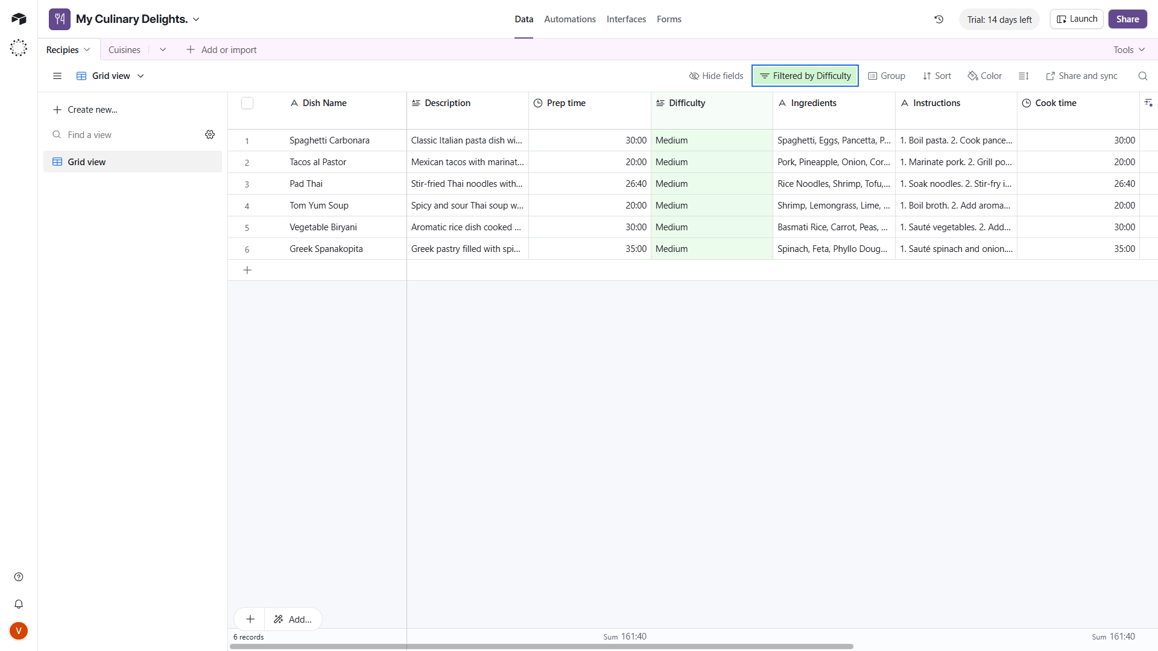

Task 2: Sort for Clarity (Categorize and Rank Data)
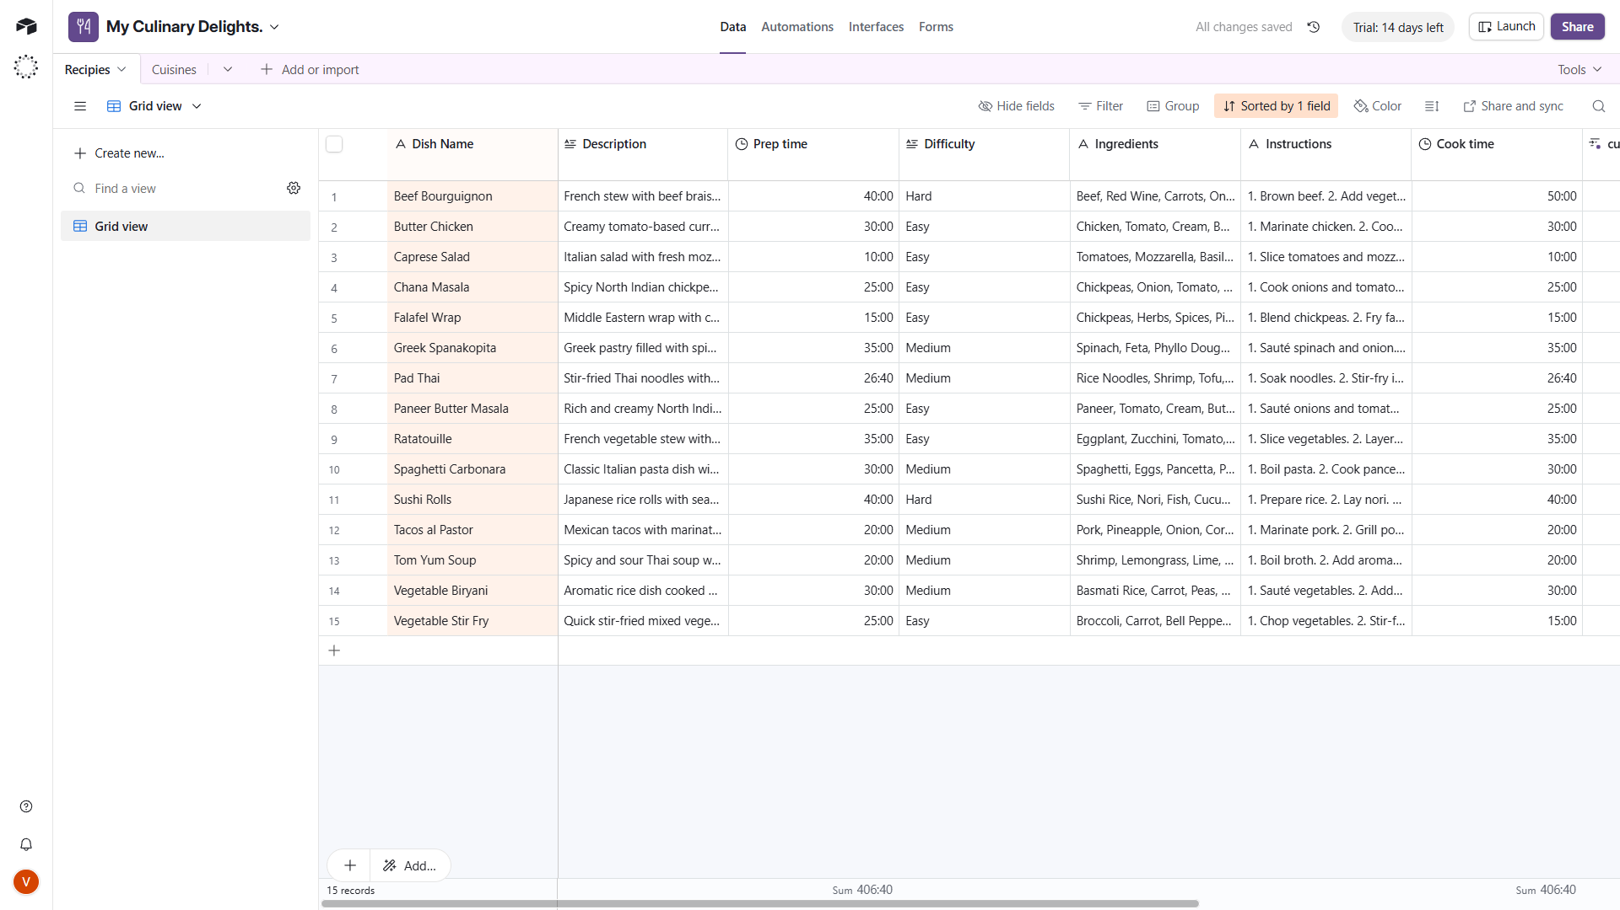

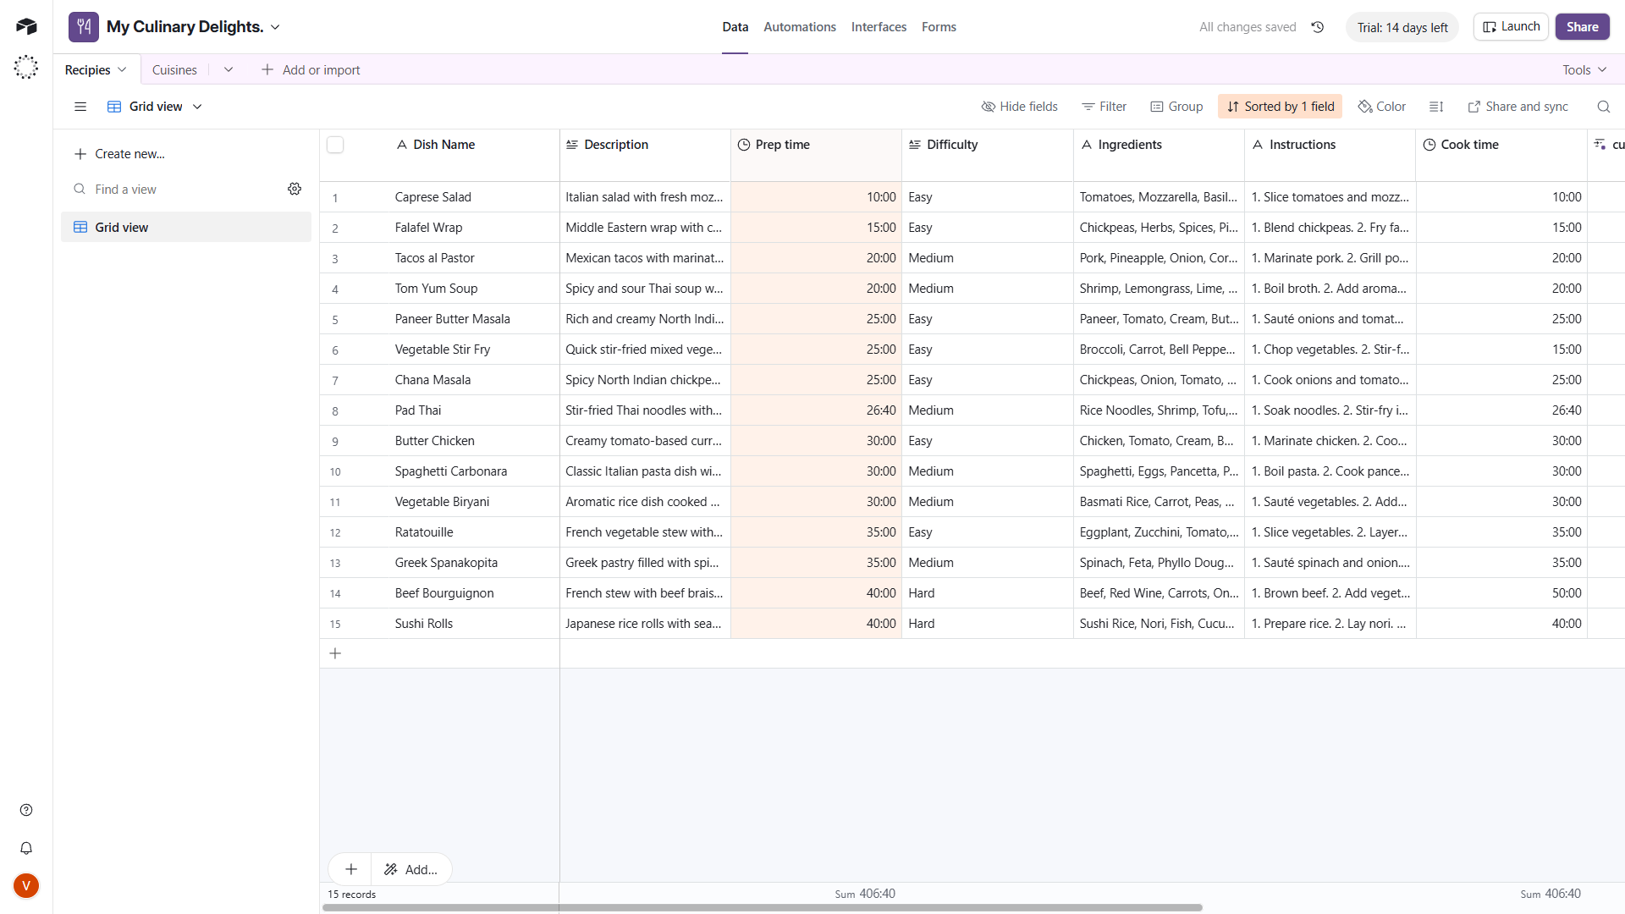

Task 3: Group Like with Like (Classify and Structure Data)
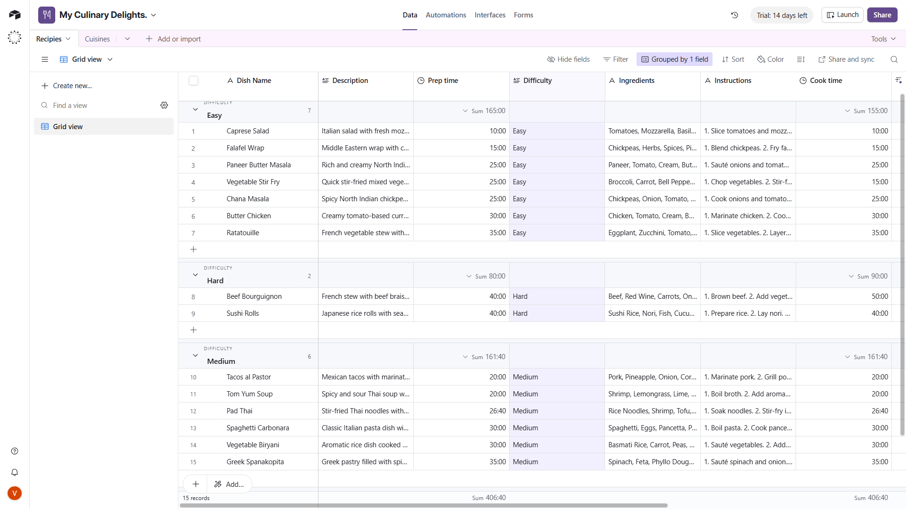

Task 4: Craft Custom Views for Insight (Visualize Data Relationships)
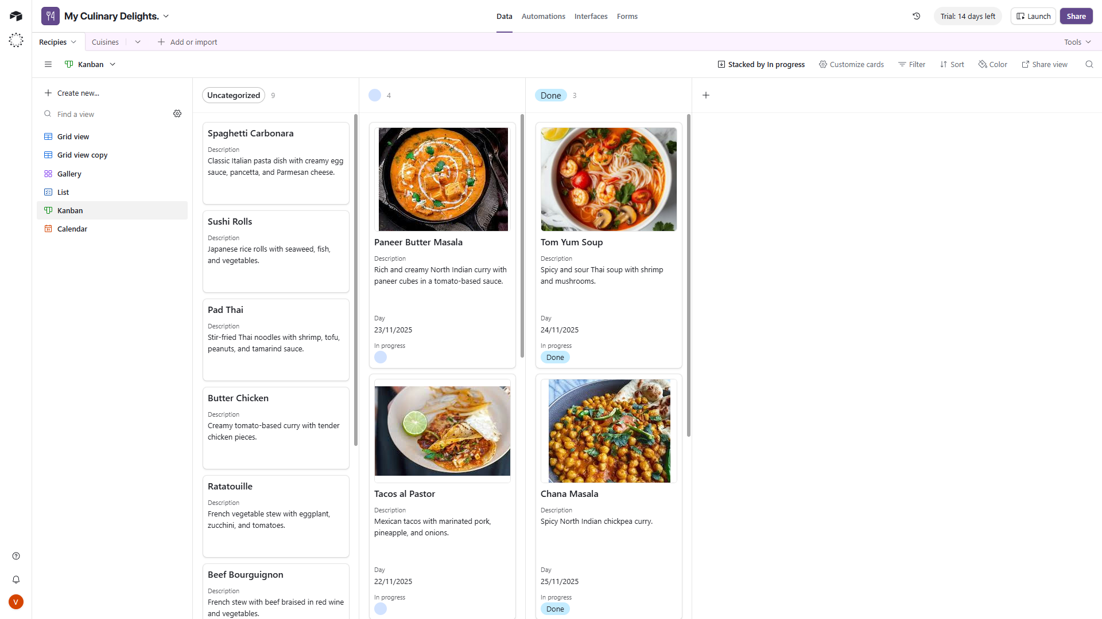
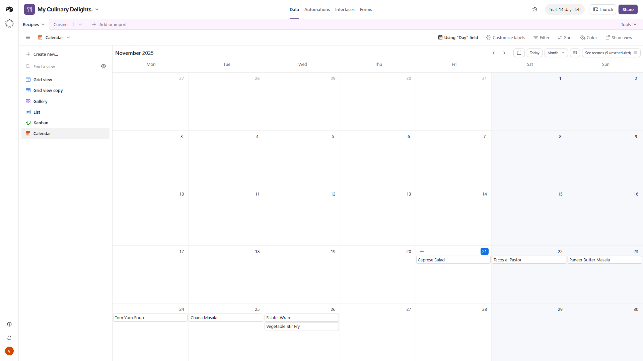
Task 5: Color Code for Meaning (Enhance Data Interpretation)
